EVENT INFORMATION
Program Description:
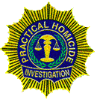
Advanced
Practical Homicide Investigation® Seminar
Grapevine, Texas
Nov 18-22, 2019

Presented by the Grapevine Police Department
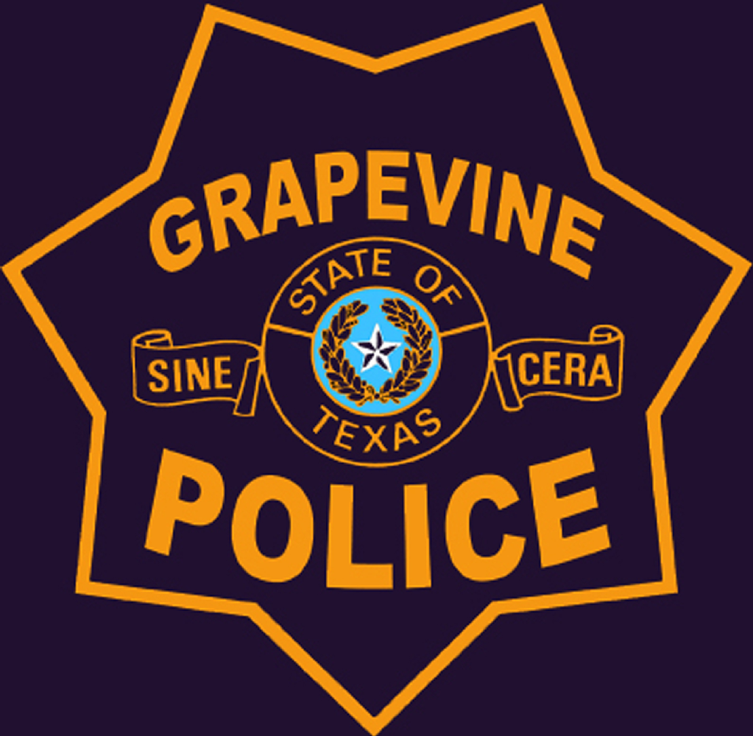
and the
Grapevine Citizens Police Academy Alumni Association

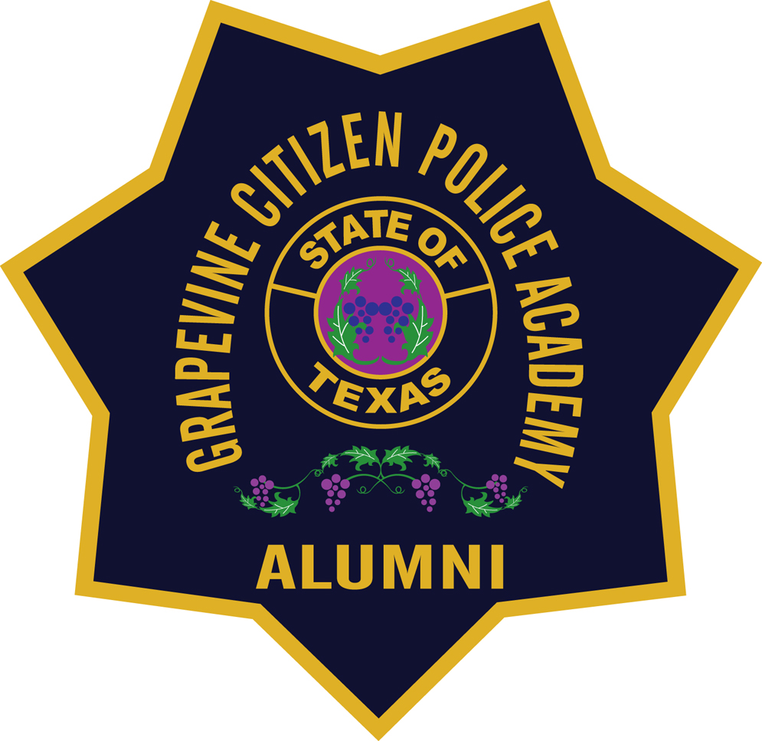

This seminar is an intensive program based upon Vernon J. Geberth’s personal experience as a New York City Homicide Commander, author, lecturer and consultant in death investigations, extensive research of written materials in the field, and personal interviews and associations along with experts in the sphere of forensic science and criminal investigation.
The Advanced PHI seminar, which includes three other experts in the fields of Aquatic Death Investigation, Major Case and Cold Case Homicide Investigation and a Deputy Chief Medical Examiner who will present The application of Forensic Pathology to the investigative process. The Cold Case section will further enhance and develop the skills you acquired in the Three-Day PHI seminar. Topics include various equivocal death investigations, cold case homicides, complex homicide cases involving missed opportunities investigative errors, and practical examples of how to apply advanced forensic techniques to the case, presented by nationally renowned experts. A Board Certified forensic pathologist will present the various medicolegal factors involved in death investigation. There will also be a discussion on Criminal Investigative Analysis and application of abnormal psychology to the investigative process.
More information is available at: P.H.I. Investigative Consultants, Inc.
Advanced Practical Homicide Investigation® will feature Vernon J. Geberth, and guest speakers. The fee includes the textbook Sex-Related Homicide and Death Investigation: Practical & Clinical Perspectives Second Edition for each attendee. Location: This five day seminar will be held at the Embassy Suites Dallas - DFW Airport North Outdoor World at 2401 Bass Pro Drive, Grapevine, TX. The seminar hours will be 8 a.m. to 5 p.m. each day.
This all-suite DFW Airport hotel is two miles from the Dallas/Fort Worth International Airport and close to Highways 635, 114 and 121. Embassy Suites is adjacent to dozens of fine restaurants, entertainment venues, and shopping. Free shuttle service from/to DFW Airport is available via Embassy Suites shuttle.
Where to stay: A block of rooms is available at Embassy Suites for $164 per night. This price includes a cooked to order breakfast each morning and beverage at the Manager's Reception each evening. Telephone: 1-972-724-2600
Go to: https://embassysuites.hilton.com/en/es/groups/personalized/D/DALEMES-GPD-20191117/index.jhtml?WT.mc_id=POG

Mention GPD: Practical Homicide Investigations Seminar if registering by telephone.
Hotel Reservations must be made by Monday, October 28, 2019.

REGISTRATION SEATING IS LIMITED

Advanced Practical Homicide Investigation® Seminar
Grapevine, TX Nov 18-22, 2019

Presented by the Grapevine Police Department
and the
Grapevine Citizen Police Academy Alumni Association

This is a Word template. Populate fields with your information and save file as your name. Then email the completed form to pdregistration@grapevinetexas.gov. Register early to guarantee your seat. Past seminars have sold out.
Legal Name:
Agency:
Address:
City: State: ZIP:
Office Phone: - - Cell Phone: - -
Attendee Email:
PID: Date of Birth: :
40 hours of TCOLE credit for Texas Officers.
PAYMENT INFORMATION: 5 day seminar $800 before November 1, 2019; after November 1, 2019 the fee is $850.
Paying by credit card
Name on Credit Card:
Credit Card Number:
Expiration Date: Month
Security Code:
Payee email:
Paying by check
Make check payable to: GCPAAA or Grapevine Citizen Police Academy Alumni
Mail to: Vicki Andrews
Grapevine Police Department
1007 Ira E. Woods Avenue
Grapevine, TX 76051
Email questions to: pdregistration@grapevinetexas.gov or call Vicki Andrews at 817-410-3200.

